Thesis Title: Introducing Student in the way of thinking Database
(Dissertation)
Student Number: 77248912
A dissertation submitted in partial fulfilment of the requirements of Leeds Beckett University for the degree

Author: Manvir Kaur

MSc IT Dissertation 16691-LTP202110

January 2022 Submission

Abstract

Developing critical thinking in the student, always taking challenging task, so with the help of visual aid learning, online learning, collaborative learning, mobile learning is one of the best method to deploy the critical thinking amongst the student community to thinking towards the databases system, mostly student in these days using mobile system, and likes to develop and integrates android mobile applications, university content management system and online learning content system considering piece of cake by using the mobile based technology. Mobile database known as SQLITE database which is automatically integrated with android studio, emulator and java SDK installed to proceed the android application, this thesis only present the design part by using the android studio. Future works requires to deploy development part by using the SQLITE database system. Primary data has been taken from the online learning system and secondary data has been collected from published research articles, from peer review journals, and IEEE journals sites & ACM journal publications sites. Methodology of this research based on android studio database application design which is based on SQLITE android studio design part. Result and analysis has been taken to compares and critical analyses the android mobile development application with other mobile applications. Future research requires to improve the android studio emulator and java SDK because it contains various issues and compatibility issues with operating system.

Student Declaration

This research is my own effort research work, findings and other development is originally developed by me, this work is not going to part of any funding agency and stakeholder, this research does not harm any human being and any research scholar during development of research. Project development phase I have learns online video lectures to build my skills. My teammate and supervisor helps me at every step of this dissertation without there this is not possible to be done on time.

Manvir Kaur

Acknowledgement

My teammate and my colleagues helps me a lot by writing this innovative and comprehensive research work, I thanks a lot of my parents specially my Mom is very pretty women in this world, without her prayer nothing is possible, I respect a lot of my mother and my teacher and supervisor in this regard.

Table of Contents
Abstract 2
Student Declaration 3
Acknowledgement 4
List of figure 8
Chapter # 1 Introduction 9
Distributed Database Architecture with NOSQL 10
Behavior of Mobile Network database system 11
Learning Management System and Mobile Device support 11
Health Management System with web based and Mobile application 12
Mobile English Teaching information system based on edge computing 13
Mobile Database system application with Mobile development 13
AIMS & Objectives of this Research 14
Chapter # 2: Literature Review 15
Introduction: 15
Related Work 15
Introduction Computational Thinking 16
Multimedia database application in classroom teaching 16
Critical thinking 16
4-types of database system 17
Oracle database 19C 17
Resources of Educational value of web plotting for three-dimensional thoughtful 18
Promoting critical thinking with group work 19
Thinking Maps 19
Data driven Learning 19
Database design 20
Database Development 25
Mobile Database Management System 26
Importance of Mobile database 27
DBMS for Mobile Devices 28
Mobile APPS 31
Conclusion of Literature Review 32
Methods of Research 32
Chapter # 3 Methodology 33
Introduction 33
Research Philosophy 33
Data Collection and Interpretation 34
Data contains: 35
Research Strategy 35
SQLITE Architecture: 36
Creating Android Project 37
Content Provider and sharing data 37
Android SQLITE database component 37
Data Collection Method 38
Primary Data: 38
Secondary Data: 38
Data Analysis Method 39
The Effect of Android Studio 39
Automating and Analyzing Code in Android Studio 40
Database SQLITE Mobile Application 41
Outcomes of Database APP 42
Predicted Application outcome: 42
Sources 43
Ethical Concern 44
Chapter # 4: Result & Analysis 45
Installation of android SDK 46
Installation of Android Gradle 46
Installation of Emulator 46
Issues & problem in Emulator 47
EMULATOR installation process: 47
Android Application 47
Google Play Store 48
Android Operating System 48
Android SQLITE Database 48
Flutter Smart Code Dart (Plugin Configuration) 49
Main Activity Java Class 49
Android Manifest XML 50
Implementation in Android Studio (Result) 50
XML Code View 51
Example Unit Test Java Class 52
Setting Gradle for Android Studio 53
Result 53
Analysis 54
Chapter # 5: Discussion & Conclusion 57
Conclusion 60
References 61
Appendices (CODE) 67
Reflection 71

List of figure

Figure 1: Database requirement analysis
Figure 2: MYSQL Schema
Figure 3: DB Forge Model
Figure 4: DBFORGE MySQL
Figure 5: DB Forge Studio
Figure 6: Mobile database pattern
Figure 7: Host DBS
Figure 8: SQLITE Database Objects
Figure 9: Predicted outcomes
Figure 10: Android studio
Figure 11: emulator installation wizard.
Figure 12: User interface of application
Figure 13: Main Activity Java class
Figure 14: Android Manifest
Figure 15: Database Design application outcome
Figure 16: activity xml
Figure 17: Example unit test java
Figure 18: setting gradle db
Figure 19: Outcomes

Chapter # 1 Introduction

Introducing the students in the way of thinking the database design concepts, by deploying the critical thinking approach to optimize and engage the students. In these days students wants to engage mostly in mobile application development. By visual aid to learn various technology that enable the user to engage on certain period of time to learn new skills and new technology programming pattern and rules. The development of advance database tools and technique has been used with developing the new software technology. To enable the student to learn and think new skills but first engagement of student should be allowed to determine the processes in order to execute the database learning objects. The objective of learning new database technique and method that admire them for new activity based learning. (Romashkova, 2019) The solution of management information system which enable the student engagement and establish the cognitive thinking processes. The process the visual aid thinking process has been done with various visual tools and technique. The database learning visual various tools available online to do the various functionality and objects and enable the thinking process of the student and engagement of various visual learning has been processes and analyzed. The resource management in mobile computing and database development process has been indicated and analyzed in various terms. (Amasha, 2021) , the development of java based web application for mathematics learning is used widely by the student community to enable their critical skill to learn new mathematics concepts technique. Beside this various web based application is available to learn database concepts and methods without delays and wasting of time. The purpose of this research is going to establish the critical thinking concepts amongst the student community to learn ne advance tools and method. The development of mobile application with android based application to achieve the goals of new advance technology and enable the user to engage with the new, the concepts of programming with advance tools and technique has been used to engage the student activity in order to obtain the desired outcomes. The development of java web application which operates on SQL server to handle the various mathematics operations and enhance the learning capabilities of the student in advance manner. In order to achieve outcomes of the database functionality would be better framework to draw the attention of the software solution. (Li, 2019) Cardiovascular disease leading to the bed of death, mobile health database management system introduced in china to enable the various health professional to get the idea about the patient history and patient monitoring system, the database system connected with central database server of hospital and engage the doctors to verify and validate the health performance of the patient to get the idea about the patient health activity. However the management of cardiovascular disease to manage and organize the healthcare system in china & engage them in order to organize the system efficient management of cardiovascular system. MobiCardio enable various efficient management system to handle the various clinical trials, the multi sensor device connected with mobile system and access by the patient to enter the health related data in the database system. Backend online database system has been connected with mobile Wi-Fi system to send the real time information to the health professional. Several ongoing features has been used to admire the services of database driven approach to achieve the development process. Machine learning based analytics method has been analyzed in this research to predict the exact death toll rates.

Distributed Database Architecture with NOSQL

(Rodriguez, 2017) distributed architecture of mobile based GIS application using the NOSQL database application execution method, that extract and transform the exact geographic location from the NOSQL database, which considering the largest data storage platform in these days but comparatively with relational database popularity does not decrease. The relational database has been effectively works on creating web based application by using the JDBC connector to connect java class’s backend and frontend java and JSP object streams. The geographic information system is requirement of every node because backend Google location has been connected on them in order to optimize and organize the new objects, the purpose of geographic information system has been engaged the student to search the college and campus location and search the food order locations and other financial related services has been used. The purpose of application has been used to present the map and other details of the system in which user interested. Information could be includes location based events such as other pertinent information that help to organize the information database design system. The database design offer flexible level of design capability to organize the objects in less time frame, but the issues and challenges still being a part of the system. NOSQL MongoDB has been used to design the Geographic information system schemas, the storage capacities of graphics, charts, text and other multimedia database in NOSQL is very good. Because multimedia database needs time process and organize the object into the database system. The use of MongoDB use of NOSQL database system. The development of NOSQL database management system uses to the development of NSOQL and SQL database system has been eventually comparison wise good. The exploration of new advanced technology to deploy the new inventions builder and floors, classrooms, to achievement. The geographic information system obtained to requisite the new user current locations. The implementation of Node.js system programming used to achieve the outcomes of NOSQL database.

Behavior of Mobile Network database system

(Qiao, 2018) The characterization flow of application with user behavior mobile application to monitor the status of network. Traditionally the internet service provider used to monitor the status of network. Various SQL based method has been used to query the big data, action queries to optimize the network performance of database transaction used to achieve the monitoring process by using the action query. The collection of storage and processing and analyzing them with management function to cope the tremendous amount of data and information processing by query the database system. The future of wireless network has been organized and monitor on priority of different protocols. The use of mobile big data analytics various machine learning prediction method has been used and administered. The process of mobile big data application achieve the characterize objects to propose the framework of advance database management system. Testing the real time mobile database system various database testing models has been used to identify the nodes.

Learning Management System and Mobile Device support
(Upshaw, 2019) Various learning management system web based tools and visual aid tools has been used to establish the critical thinking objectives amongst the student community. The thinking objective has been established amongst the student community, in online database environment to process the potential problems. To investigate the database learning approach has been recognized with online learning tools with graphic aid technology. Various tools offering online database designing services to optimize and organize the database performance. Various large websites offering user friendly environment to develop mobile application that support both web based and mobile based integration such as Amazon, Walmart, Best-buy target various user friendly websites. Mobile sites support various educational institute to support the student to capture the critical way of thinking in order to learning reverse engineering and forward engineering database concepts. Mobile computing offers various support to process the on demand computing services over the mobile node user. The use of various mobile based learning approach has been used to analyze the database operation. The use of Moodle, and learning management system of various educational institute does not fully support to the student because there is no visual and graphic aid tool available to guide them properly and engage them to serve their critical thinking purposes. The use of blackboard learning does not fully support to the student during the class session of database system, so there is need to develop some aid and tools that engage them in order to optimize the mobile based learning and mobile application based learning approach. The process of successful database learning system to execute them on priority various mobile app has been introduced to learn new and advance approach of database management course. The use of mobile and mobile data has been increase in these days to process the large amount of information various mobile based apps has been available in Android platform and Apple platform. The optimization and query processing method has been deal with intelligently. University LMS system only support the lecture content, slides, presentation content, but there is not availability of any graphic tools to enhance the critical thinking approach in between the student community. Various research consumer has been worked to efficiently works on development of advance database tools and technique, such as SQLITE and POSTGRE SQL used as tool to design the mobile based database application to engage the student to deploy new invention followed by learning the new programing skills. The android studio offers GUI based platform and user friendly environment to student that able to design the graphics application of database system for record keeping purposes.

Health Management System with web based and Mobile application

(Villanueva, 2021) Health management system with mobile based and web application based that used to administer the patient health with various attributes. Government provincial health department used IOT based system that attached in Hospital central database backend SQL database has been used to store the operation of various patient health record. The management of health record system with no instance and no delay has been used to optimize the health related issues and problem has been analyzed to proceed the performance of patient with central database of the hospital. The mobile based web application used to facilitate the health workers also to communicate and correspond them with each other. The follow up consultation method schedule on vaccines with consultation of prescribed doctor and health minister under supervisor the online reporting has been also delivered to the ministry of health and sciences to check and update the performance of the health department as well to identify the performance of doctors and hospital management.

Mobile English Teaching information system based on edge computing
(Jiao, 2021) mobile edge computing establish in 2013 still the research & development technology works on mobile 5G technology to remove the problem and fix the issues and challenges. The implementation of mobile based technology to learn English information system, this application support foreign students that does not well known the English language. The English teaching information web based application support visually to students that learn new skills with advance development of new roles. The advance vocabulary building based learning approach has been used to develop the critical thinking between students. The development of new propose approach for deploying the new technology by present the visual aid based system to admire the student community. English language based learning also used to support the learning capability of database concepts with advance tools and method.

Mobile Database system application with Mobile development
(Somantri, 2020) ZMPT voltage sensor used to analyze the electricity tariff which connected on mobile sensor and sensor connects with central database system. Certain database operation has been performed in order to sustain the development of electricity traffic monitoring. The system is able to monitor the electricity voltage and also present the classified report which able to analyze the electricity consumptions on web based application, the system used to impress the household electricity saving purposes.

AIMS & Objectives of this Research

- The aim of this research is going to develop the critical thinking of the students that takes interest to deploy new database application followed by mobile based technology. Today mostly 99% student community used mobile computing environment to process studies objectives and goal. To enhance the database learning skills and database development skills various visual aid and tools has been introduced in this research.
- The objective of this research is to develop SQLITE based mobile app which uses the android studio platform.
- The goal of this research develop the GUI based database learning approach with effective mobile computing platform environment.

Chapter # 2: Literature Review

Introduction:

Literature review part of secondary research data, which involves to identify the research approach and research method, it also useful technique to identify the research development system. Literature review conducted to solves the problem of student thinking and approach towards the database management. This research literature conducted to review the latest trends and technology to develop critical thinking approach to establish database management system.

Related Work
The effect of mobile based learning approach has been working effectively in these days at university academic level student. (Gezgin, 2019 ), this research explore the student engagement on mobile based learning approach that effectively works to introducing the student to deploy database system. The success on database management system, research conducting on 36 student carried out university in turkey. Mix method has been used in this research, such as qualitative and quantitative research approach used, pretest and posttest method with quassi experimental model to analyze the qualitative data of research, the indepdent t-test paired sample were tested and analyzed, after literature survey, it is recommends in this research that mobile based learning approach is effectively used to establish the well versed thinking capability towards the development of database system. In mobile based learning method fact to fact training method has been used to test and verify the skill of the student and the access interest of student has been analyzed and visualized. (Scardamalia, 1992) In this research class room supported with computer system which achieved to establish to goal of thinking and learning technology by practically deploying the database management during the class session, the approach effectively works to take attention towards the student to monitor the learning capability and deploying new capability. The database designing skills needs to develop in more attention way to establish the goal of new skills parameter that executes on priority including social cultural network. (Avdic, 2010) Searching reference database with student experiences that shows the vast amount of high quality references during writing paper. Reference database is not suitable and the reference of working of student is not beyond the marking of new goal. The objective of this research to deploy the reference database that used to taught the student during class session which works well to achieve the great outcomes. The objective of this research to elaborate the problems of the student that experience the students on university database with reference material. The researcher used unified theory acceptance with use of technology, web based survey has been carried out in total of 150 students achievement university of Sweden participated in this survey the result was analyzed based on median values of research.

Introduction Computational Thinking
(Hambrusch, 2009) Development of initial evaluation courses to establish the computational thinking approach amongst the student community , introduction to computation thinking this course was designed by computer science faculty to fulfill the college requirement. Computational thinking process in collaboration of computer science faculty that computing the principles of computer science & technology. It uses python programing libraries to teaching computational thinking using basic programing concept of database management system, the concept of database simulation and database visualization in terms of database design to create new software technology which uses to stores the various records of the community. Initial evaluation course uses to develop initial computation thinking capability to students that takes interest to deploying the record management system.

Multimedia database application in classroom teaching
(Chien Yu, 2011) In classroom teaching various tools and technique has been used to teach the database courses, student takes interest not in theory based subject, alternatively student’s takes interest in practical implementation of database system. Various educationist deploy the searching information method to deploy the conventional methods that functional on multimedia method. Educator deploy to creates the multimedia recorded system which eventually creates interest in the student community by using the multimedia database application, multimedia database files includes, text, graphic, image, animation sequence, video, audio data. The strategies to develop multimedia database system by using the various multimedia tools and technique method.

Critical thinking

(Thinking, 2021) Essential critical thinking objectives to establish the following skills between the student grades of undergraduate and graduate students. The 21st century curriculum tools to teach the students effectively including critical thinking approach.
- Thinking problem solving skills
- Communication & information skills
- Interpersonal and self-direction skills
- Collaboration skills
- Computational & processing skills
Student collaboration mechanism effectively works to arrange things in advance manner. To sustain this goal the development of curriculum activity establishing approach was mainly works to sustain the student brain by development of practical skills of database approach. Various student approach to deal with aspects of learning new database advance skills, such as NOSQL queries and SQL queries, the advance database application needs to execute with no time delay. Mainly the reason to choose the database learning goals. So there is need to learning the new database curriculum activities, in these days mostly database application available on cloud computing various cloud application works well, such as Amazon, Azure, Oracle is one of the riches online database platform that achieve to sustain the effective environment in which students can take participate to establish new achievements.

4-types of database system
- Network database
- Hierarchal database
- Object oriented database
- NoSQL and Non-Relational database
In these days popular database is non-relational which deals on large amounts of database storage system, NoSQL database takes varieties of forms that allow the user to store and manipulate large amounts of database of unstructured and semi structured database such as key values stores document stores, graph store.

Oracle database 19C

Oracle database system is essentially considering the best organize solution to achieve the sustainable result, oracle database stores enterprise application to store huge amounts of data storage with scalable functionality. Oracle database system is the way to create the new thinking and objectives on the student’s motives to sustain the new outcomes and goals. It offer new features and services that includes
- Application development (web and desktop)
- Availability online to everywhere
- Big data and data warehousing
- Database system overall functionality including SQL queries
- Diagnositibility
- RAC and GRID
- Security & performance
- Application development general including JSON, SQL, Application Express
- REST enabled SQL support
- Web sources modules
Oracle application express offering the services of SQL PL/SQL query support over rest running self-describing java script applications system including authentication models.

Resources of Educational value of web plotting for three-dimensional thoughtful
(Manson, 2014) Web mapping method which involves to establish interest in the student community, in web mapping concept various database application available online that practically achieve the platform to establish various web based record management solutions applications, this kind of application leading the success goals of effective planner that achieve the student thinking interest. Static maps offering the dynamic map querying including three dimensional analyses. Web mapping support in development of student creative application development that used to take attention in database designing principles online ER model creation services, data object storing services and JDBC connectivity in java application. This research examines the classroom three dimensional resource management system in which it leads towards the educational values that uses to draw attention in the student community. Web mapping service effectively works well to retrain the subject evaluation system and students motives development.

Promoting critical thinking with group work
(Fung, 2014) primary student and higher class students takes interest to establish the interest in the development of new database management system, with new invention of technology that support graphically with user friendly environment by using the IDE tool, in Hong Kong primary school make reasonable argument with various technical skills in the age of 11-12 years student, problem solving activity collaborate the projection in the UK in the SPRING project, the finding reported results reasoning test including graffiti task raveled the student critical thinking objectives and motives.

Thinking Maps

(Maps®, 2021) Thinking maps is pattern of 8 visual set of pattern that correlate the specific coginitive processes. It used to grades area and build the critical thinking and problem solving skills that compensation to communication skills of every domain. The visual language for learning, the visual aid is the only tool that engage students to think critically and organized new things in advance correlation way.
- Double bubble map
- Multi flow Map
Graphic organization charts is helping material to do the things in right direction. The way of developing advance database skills and advance database development process in according to achieve the web development goals using Java JDBC functionality and Oracle tool, Oracle database support all functionality web application based database tool that install graphically in windows operation system in access using the web browser protocol.

Data driven Learning

(Hadley, 2002) Data driven learning approaches introduces in EFL classroom, that prominent on covering the pertinent issues and development in the field of grammar, (Estévez Ayres, 2018) data driven learning approach visually guides the student to takes interest towards the thinking goals of new inventions and new ideas, this approach was visually guide the students which available on demands learning to leads the system of data driven learning approach in which various database method and database design method has been learn visually students thinking new goals and new ideas about the mobile based learning aids and mostly student in these days think about the ways of mobile based learning situation. Database system is part of various component MYSQL database is mostly popular to develop web based applications. Beside this mobile learning method has been introduced to achieve the sustainable goals of versatility and volumes of data storage. Java programming achieve the goals of backend database operation programming in which different tools and method has been designed, java tools has been part of ORACLE database that connect various web sites links to database operation such as JDBC driver operations. JDBC connector is used to connect the java classes to database classes. JDBC used in MYSQL platform as well as ORACLE database platform. Mostly the database connector downloaded from websites, freely available to sustain the various goals and operations. In modern database design concepts today most of the user is using mobile application not desktop and tablet so the part of mobile generation, mostly student engaged in development of mobile app that executes on mobile operating system such as Android based and Apple based mobile system. Mobile generation user thinking about the modern goals, the critical thinking has been occurred on demands of development of various database applications. Mobile applications that executes on various goals that used to sustain the various operations.

Database design
(Modeling, 2021) Database design is the collection of various database components in which differs software entities has been design to record the online database system on the particular physical location database system via using some programming tools & method.
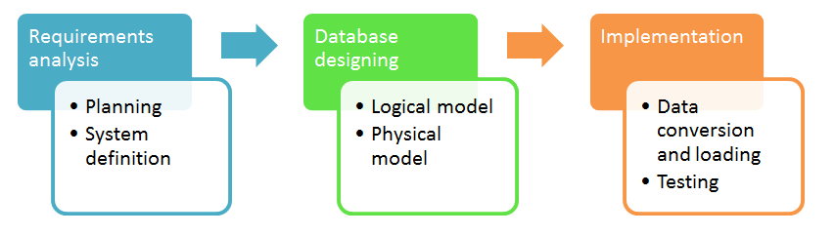
Figure 1: Database requirement analysis
Requirement Analysis:
Planning the database design that achieve to sustain the concept and concerned with planning of entire database development life cycle. Various information system has been designed of planning component and requirement analysis system which based on different goals & technique.
Database Design:
Logical Model: the logical model of database system used to achieve the various database model in which entire design put on paper not physically design in system, physical implementation concerned on different goals and technique such as various physical database operation has been achieved on database management system.
Physical model: physical model of database design copied the method of logical design in which database entities and attributes, cardinalities has been finalized.
Implementation:
This stage relational database has been implemented to communicate with different entities and corresponding to achieve the goal of database communication. Database implement in two stages.
- Relational database
- Non-Relational Database
Mostly non-relational database has been implemented on MongoDB database platform, in which modern database concepts has been achieved with large amount of database has been exist.
Relational database is older concept of database management system but still in practice and very popular because of web based application easily implemented and developed without any error. MySQL database and SQL Server database management server has been used widely in these days to develop web sites application and desktop based application.
TWO Types of Database method:
- Normalization Method
- ER Modeling
Normalization method is used in relational database concepts to remove and redundancy and repeating values of entities in the attribute design. The concept of normalization is still very popular and common in practice because of reliability and confidentiality of the database system. Normalize system used to clean the database table and normalize the relationship between the entities.
ER modeling database design older concept used in relational database management system, with the advancement of forward engineering and reverse engineering software development concepts that enable the user to establish the modern development of ER modeling concept that automate the development process of database management system.
Forward Engineering
Forward engineering used to enable the system create a script of database model. Database script used to alter and modify the modern concepts of the system, the script is used to create the database and automatically creates the database tables and fields using MySQLdump db_name command.
Creating a Schema:
With the help of ER modeling the schema has been automatically enable to creates the database schema within the MYSQL database management system, forward engineering SQL create script by using SQL create forward engineering script.
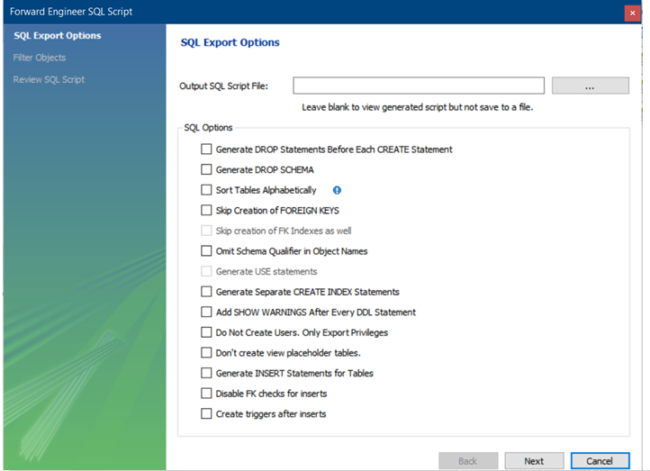
Figure 2: MYSQL Schema
Output SQL script file has been generated automatically, in which the software engineer able to copied the script as well, for tutoring purposes. The object of SQL script which used to establish to goal of database operation.
Reverse Engineering
In reverse engineering concept the model of database designing concepts has been used to initialize the database system, reverse engineering concept used with the help of DataEDO enable the use to create the database documentation. It needs the database schema to easily describe the database development process and it enable the various user to do the task with operation processes. (tools, 2021)
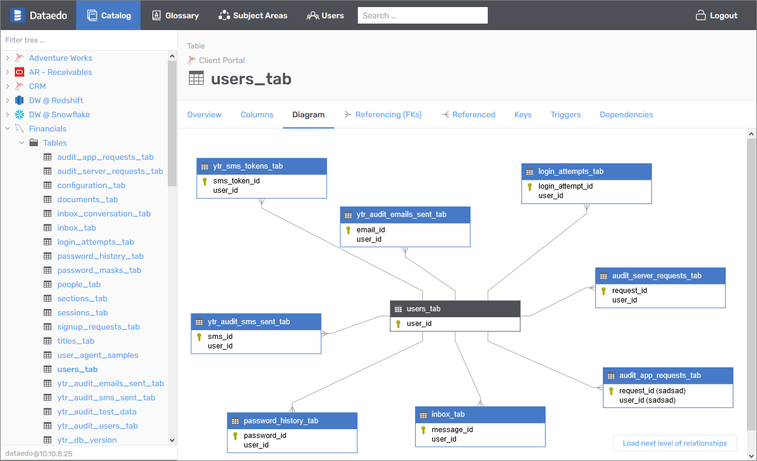
Figure 3: DB Forge Model
DB FORGE for SQL studio
SQL server considering powerful IDE tool for SQL server management system which operates and automates the database management systems, and proceeds the system of implementation.
dbFORGE studio for ORACLE
DbFORGE studio is considered powerful IDE tool to develop powerful database applications. Oracle developers increase the PL/SQL coding speed. It provides the management system application. (tools, 2021)
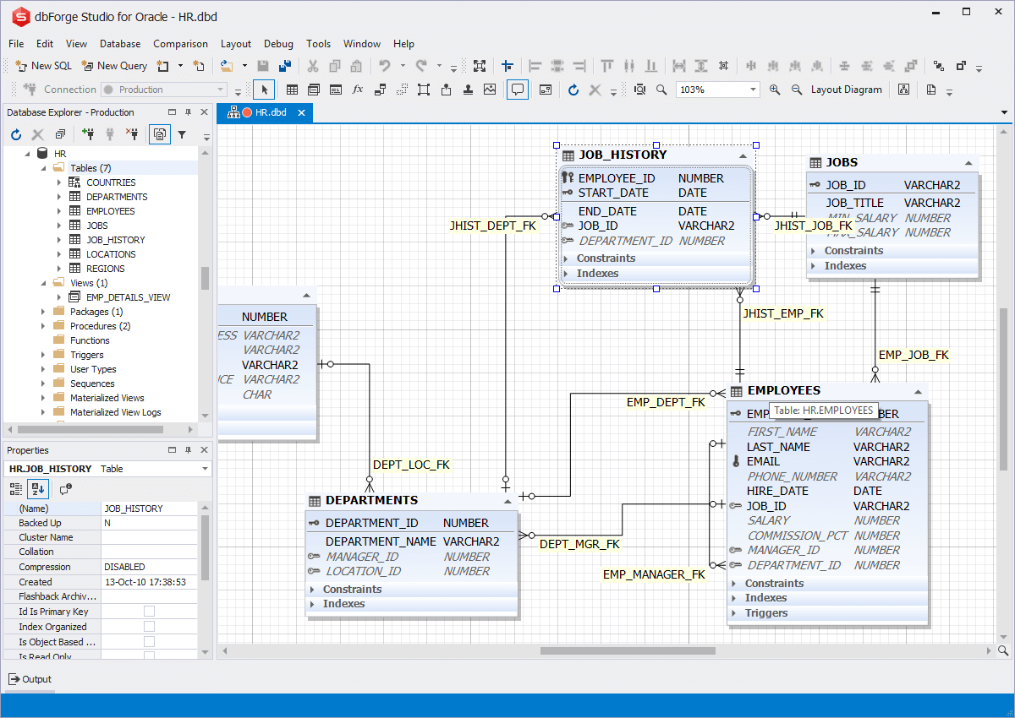
Figure 4: DBFORGE MySQL
DbForge studio for MYSQL
In dbFORGE studio that essentially being used for MYSQL server, in which the user able to creates, analyze, reverse engineering, print and customize database development tasks.
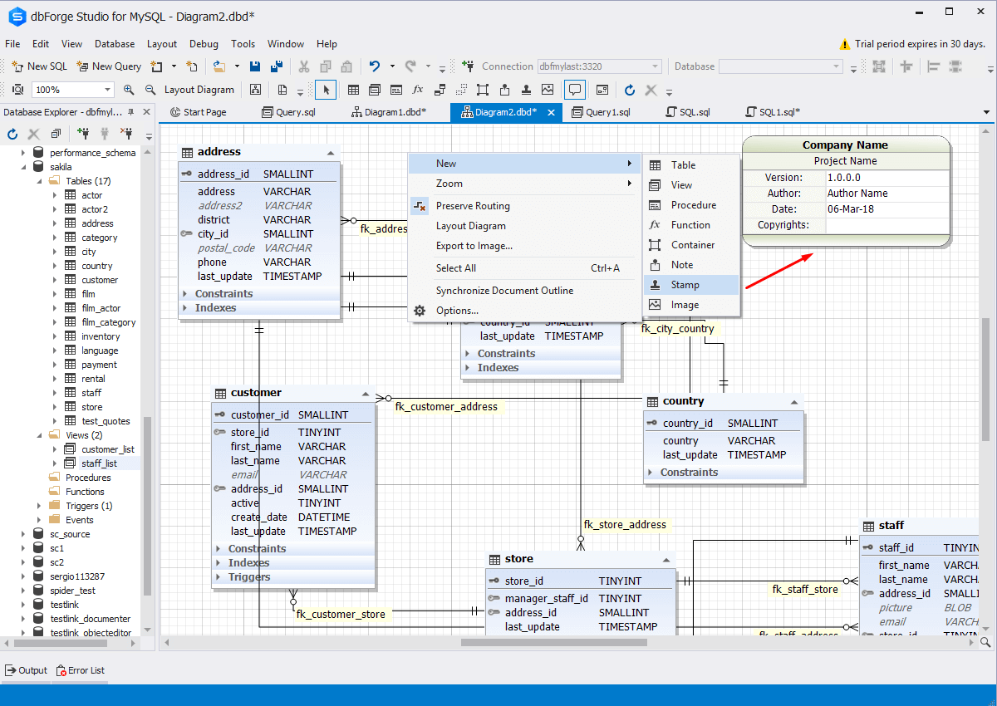
Figure 5: DB Forge Studio

Database Development

(Ahmad, 2021) Road and high system development processes various civil engineer takes initiatives to do the planned system of road and safety development. However the scope sliding achieved on 2.5% on ratio of development of road infrastructure experienced with previous dataset. Physical development of database applications used to achieve the various goal and operations. NICE recommends the database development process that leads towards the original and sustainable goal. The achievement of actual database implementation retain with NOSQL server and MYSQL server management concept, various civil engineering sites database has been implemented in MYSQL platform. The advancement in the development of database management system. So in these days young generation is part of mobile user, mobile database application leading towards the goal of new ERA.
Mobile Database
Mobile database support, transpose, physically separate the attributes and other information that available on the internet site. The database server incorporate to achieve the goal of corporate database system, mobile database platform includes, PDA, LAPTOP, MOBILE, in which two ways communication links has been designed to mitigate the schemes, the evaluation of database system that certainly work on different platform of database management system and development process. (Madbouly & Yasser, 2021) mobile computing consider the new concept that achieve to store and retrieve the various user queries on demand computing platform, the on demand computing platform services retain to achieve the development of online query processing system and input and output operation has been achieve with the advance database management system concept. The development of database system has been used to achieve with cloud computing platform, mostly the Amazon cloud is considering one of the richest cloud storage system. so the awareness has been establish with cloud computing concept, the development of modern database applications has been achieved to enable the user that establish various goals and operations. The purpose of this study to present the quantum game theory concept selecting the most efficient database system to recover the computing resources, transactional issues on real time distributed database system in mobile computing environment. (Singh & Shanker, 2021) In real time processing system the issues has been recognized, and identified. Transaction execution in mobile environment operate on bandwidth storage capacity, power backup, with priority scheduling policy, the concurrency protocol commits to pointing out the check point and other information. The performance has been tested on mobile distributed database system addressing the performance issues on distributed database platform. in fact the paper provides the on ground reality prediction services that enable the user to achieve with better performance.

Mobile Database Management System
(dbms, 2021) Mobile database is considered modern database system that connect mobile devices using the mobile computing platform. Mobile database is portable and physically separate from the corporate database server. Mobile database capable to communicate with the corporate database server from the remote sites to allowing the other mobile devices to connect with the database and communicate between them.
Mobile database connected with distributed computing environment that connects other billions and millions of nodes with the help of mobile cloud computing and fog computing platform. The online database system contains scalability, reliability, obtainability, and other operation services uses to obtain the various goals and operations on demand computing platform.
Mobile Database Ability:
Connect with central database server management including wireless internet operation through the wireless internet connection, replicate the central database to other connected nodes, synchronize database with other database nodes system and capture the database system from various sources manage analyze the database system from other nodes.
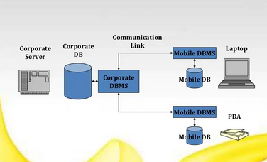
Figure 6: Mobile database pattern

Importance of Mobile database

In these days every business needs on demand computing and on demand storage services, so the on demand computing choice has been increased due to scalable and reliable database services on the cloud computing environment. Amazon cloud considering one the best and riches cloud computing services to store and integrate the database services beside this oracle database cloud is one the largest database services scalable and integrated and reliable services that achieved online service computing. (dbms, 2021). In today business needs services anytime anywhere from any device, mostly the user used mobile devices to plan their daily tasks and online transactions, mostly all banking services considering online services due to reliability of personal area network using the virtual private network platform. the planning of virtual private network that support mobile computing database storage platform by using the firewall services which provides by the internet service provider without asking to pay extra amount on them. (dbms, 2021).

Feature of Mobile database:
Mobile database offers online support, fault tolerance services which available online computing platform, if there is any fault exist with online transactions system the discovery has been automatically enabled with the new inventions and achievement. Mobile database works online with central database management system protocol. Data has been downloaded to divide the workload on them, capture the real time data form other mobile nodes, and customize mobile applications service. Application of mobile database mostly used by every business and modern technology, mostly the undergraduate and graduate student community widely used the database services in public sector and private sector. (dbms, 2021).US Army uses mobile database to record the current activity in the inventory of database system, sales person can used to update the sales data on the customer data on the movement of every object. (Chien Yu, 2011) Banking sectors 100% using the mobile database system which provides the customer on demand transactions services without delay connectivity of means of virtual private network and firewall enable network services, the virtual private network automatically enable in the mobile devices due to advance mobile application features, all of these services has been reliable integrated and updated to perform the various operations on the services of demand computing roles and achievement. (dbms, 2021).

DBMS for Mobile Devices
Power optimization, memory management, DBMS mobile devices should be able to works optimizing the least priority followed by the preferable choice. Database management system for mobile devices available every time and everywhere by connectivity of internet access.
Mobile Database Architecture:
- Users of mobile is not attached on fixed geographical location
- Mobile computing device; low power, low cost, portable
- Wireless network with reliability of VPN
- Mobile computing restraints
- Fixed host, mobile units, base stations
- Base station two ways radio installation services based on fixed locations which passed communication with mobile units and other fixed cost.
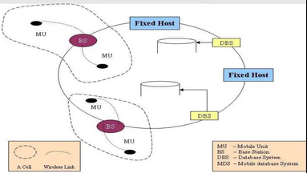
Figure 7: Host DBS

Sybase sql operation everywhere and anytime storage and processing capacities dominants mobile database with 68% share. IBM DB2 and MS SQL server compact and ORACLE 9i lite. APPLE IOS uses DataGlass including mobile database.
SQL anywhere most common practice database of mobile database system in these days beside this SQLITE has been also used.
(M. Sheerin Banu, 2021) Development of mobile application for government schemes management. The conventional government matter and on site computing system need to develop that mitigate the processes in actions to achieve the better database services. The stable mobile database system organized on mobile cloud computing database platform. The process of developing mobile applications that retain to choose the various mobile database application services that achieve to migrate the mobile database development process on DEVOPS operation on Amazon cloud services, and SQL server services also on demand platform services uses the server computing environment virtually by virtual machine system. Linux operating system services has been available on virtual machine platform that access anytime anywhere. (Lei & Feng, 2002 ) Mobile database management system suitable for mobile computing platform that exists on mobile database system to achieve the goals of success. The database management system enables various operations with analyzed the various mobile operations, mobile database is kind of distributed dynamic database that concepts of virtual server provides the services to the nodes that connected online by using GSM service. Mobile database versatility has been presented in order to think students towards the development of advance database in order to optimize mobile database system. (Weider, 2007) mobile devices used for electronic commerce and medical commerce with consecutive times the consumptions of role models has been analyzed and captured to admire the technology in advance internet system, mobile application in these days serve largest market share (Ahmad, 2021) but in these days mobile generations has been used 100% shares to deploy various mobile application by admiring their goals and achievement during their studies at graduate level. Mobile demands has been increasing in these days because all of the computer system application now available on mobile devices without any hesitation and problem, the fault tolerance and error prone during the mobile devices has been analyze and working of different mobile operating provided has been discussed and analyzed, the communication pattern based on 4G and 5G services mechanism. For mobile business applications today all business and electronic marketing is available on mobile devices and student engagement in study point of view group studies, collaborative studies is put on mobile devices. (Ghorbanzadeh, 2010) Security of mobile devices database is always concerned with various issues and challenges, security of mobile operating system that operate the mobile database applications in order to achieve the security issues and privacy concerned. Mobile database security issues concerned with various vulnerability attack that happened on before android now the issues has been resolved. Various mobile applications has been available on different mobile computing with scalable computing environment. Mobile database system in these days the choice of user and the choice of every students, that one is only choice and option that introduces the students to think towards the database system. (Gezgin, 2019) The new scalable big data system has been organized with the help of semantic web applications. The arrival of web 3. 0 has been changed the communication pattern with more visible skills and technique. Semantic data gives the machine to advance concept of database transactions and processing method. While big data system handles various problem data and situational database system. So the need of organized database communication. The management processing of semantic web application comprised with big data system on semantic layer. The adoption model processed with various on demand computing application which serves on priority computing application the goal of new science and social science worlds has been optimized and admired. The popular tools in the 2021 that configure and authenticate the different nodes on different pattern of nodes. The storage engine, query language, query processor, optimization engine, metadata catalog, log manager, reporting manager, with data utilities performance testing tools. The comparison between relational database management system and document database management system has been effectively analyzed in this research. The proposed model for mobile database management system has been discuses and analyzed.
Advantages of DBMS:
Database management system used widely to process every educational application and it also used to engage students to develop various database application including software engineering concepts. The goal of database management system has been used to organize the various goals and operations. Certain operation to process the application of database system. Software engineering tools and technique has been organize and manage with the help of database system. DBMS server offer storing, processing, securing data and file system services to the client computing of mobile user.

Mobile APPS

Mobile apps widely used for learning purposes, mobile application enable the student to learn various database concepts, the development of cost effective waste management system application that support urban cities to support civilian in the line of (Aaron & sella, 2019) waste collections, which has been major issues and concerned, by deploying the cost effective database application that support the user to help and support in different parameters. The internet of thing commonly known as IOT devices system that connected online on the internet services to enable the user to informed with database development processes. The technology has been introduced to develop the smart waste collection system with cost effective method that achieve to obtain the highest result. By making the cost effective sensor that connect with centralize database to inform the authority that the waste arise in the near location of the urban city. The concerned person of authority has been reached to organize the workflow of waste collection. Using firebase database with android studio with group to collect the entities and create the mobile application that provides the graphical user interface to the user and served with user interface ID’s. It informed the authority they reached the waste with certain amounts of time and obtain the highest result. The main advantage of mobile base application that informed the waste collection authority with the IOT devices that connected every time with internet connection. The online database system has been widely used to engage the various activities to create the different software platform application. Mostly the user of today has been recognized with mobile generation that wants to use only mobile system to solve his studies related problem. So database management system serve as tool using the mobile based technology that enable and engage the students to creates various mobile based application to achieve and obtain the studies level goal. SQLITE database considered to be portable database that used to achieve the certain result. SQLITE database is very fast as compare to POSTGRE SQL. Beside this MYSQL database has been also used to do the work with creating mobile based application and android based application.

Conclusion of Literature Review
The literature review has been analyzed and predicted with organized way, the method to achieve the sustainable database application that executes on android based mobile user. To establish and enable the critical thinking towards the introducing new students towards the database concept, so it is has been critically analyzed and observed that visual aid could be used as tool to guide the students for engagement of new database development and software development application. So the secondary data suggest that the student choice mobile application, which attract them deeply, so students of today generation wants to likes various mobile based application which executes on android phone. So student critical thinking and observation has been enable with development of mobile based database application.

Methods of Research

- Creating SQLITE database app by using the database classes
- Mobile based record layout in android layout design
- Android based database application backend SQLITE database frontend Android studio.

Chapter # 3 Methodology

Introduction

Database application deploying that support graphically to the student requirement, in which various students can take place to build interest and develop their critical skills and thinking skills towards the database application. Advance database application design that support business data management system, in academic level various database tools has been introduced to develop programing skills amongst the student community. The primary objectives of database design to develop logical and physical database system, so there are three database design phases, logical, conceptual, physical database design. SQLITE is considering lightweight database, essentially used to support student related requirements at academic level and different enterprise level. SQLITE originates with android operating system, SQLITE backend database operation beyond the android studio mobile application. Android studio used to creates the SQLITE database application, so the ideas comes from literature review secondary research to deploy the critical thinking of the students towards the database application.

Research Philosophy
(databases, 2021) Database considering basic central component of every person, it considering central module of this world, students wants to view education progress, study outcomes history, academic wants to update educational programs and update and insert new data on websites so every business and banking applications needs transactions and customer data for record keeping, so everyone required central database application that needs to promote and update database system. The database before comes on available on racks and files but there is no computer operating system and functional software tools available to record them. Data was stored in journals, newspapers, magazines, files & folders so there is no concept of storing the data into the computer, everything recorded via paper and stored in the folder and hard copy file. Charles Bachman designed computerized database in 1960, the early database stored in integrated data store items in computer, later this is shortly followed by IBM information management system database which is later known as navigational database. In navigational database both network model and hierarchical model has been available which support user to view them, which is developed by IBM computer. In later 1970 the development of relational database system has been introduce that originate with shared and relational database objects to support organization needs. Relational database shows the user records and different entities in order to obtain and verify the different records on them. In later 1980 SQL becomes the professional database language which professionally used to obtain the development of various records by using database queries, in early 1990 the SQL becomes the professional programing language of the database which now still is being used for developing many Apps and software tool and different websites. In the mid 1980’s the concept of object oriented relational database system comes with programing languages and in 1990’s the arrival of internet with popular and modern world wide websites which essentially used to obtain the outcome of desired result. All of the business demands now fulfill by the World Wide Web beside this SQL database exists to store the potential data of clients. Later the creations of MYSQL in 1995 that comes with open source software development tool and offered by database system such as ORACLE and Microsoft that is still used by various organization. In later 2000 the concept of NOSQL database has been comes with non-relational database objects that stores various records and multimedia data item with huge amounts of sizes. And later 2010 the concept of distributed database comes along with cyber security tools and technique that used to protect the top secret information of the organization and provides the security mechanism to the organization.

Data Collection and Interpretation
(N. Dorosh, 2016) Android studio comes along with SQLITE database that uses to support all of the mobile application development, SQLITE considering the richest platform of database contains lightweight key application. The specialized software application which support student needs, android application potentially impresses and admired the student community which takes deeply interest to engage student thoughts and the way of critical thinking objects for deploying new and creative database application. Almost 99% of students engage with mobile learning and mobile computing applications, so the idea comes from secondary data to establish student thinking and introducing the new mobile generation student that thinks towards the database system that leads towards the advance database system. So the development of advance critical thinking by mean of using android application and backend SQLITE database system which effectively works well to organize the things accurately. Data of student record keeping which based on student requirement such data contains in SQLITE that stores the user record contains the user name, semester info, program info, email and contact number of student.

Data contains:
- User name
- Semester info
- Program info
- Email
- Contact No
All record of student needs to store in SQLITE database table the application perform the following actions which mobile based application created in Android studio as follows:
- INSERT DATA
- UPDATE DATA
- DELETE DATA
- VIEW DATA

Research Strategy

(Vogel, 2010) Android SQLITE database applications embedded into the android studio that stores the android mobile application data and record. SQLite support standard features of SQL database which integrated on relational database concepts that executes on java class prepared statement in the android studio application environment. The data transactions and prepared statement comes along works with java classes contains:
- Main activity java class
- DB Helper Java class
- Activity main XML class
SQLITE support data types of integer, text, and real double data types which fulfill all of the desired data and text requirement of the record. SQLITE available on every android device which obtain to store all of the mobile application data and fields which essentially required later to see the result. SQL statement used to create, update and delete the database tables mostly the common SQL syntax which is recognized in earlier research SQL professional language syntax still is being used and work properly. The file system of SQLITE applications comes along with different documentation and framework that support various programming modules and framework.

SQLITE Architecture:

- Package
It contains android database package information which offer working with android database which essentially served by the java classes.
- SQLITE Open Helper
To create and upgrade the database application which needs to serve in various platform and tools and technique method. SQLITEOPENHELPER class which call on super () method in java class override on create () and on upgrade () method, on create () method called the database framework objects and beside this and on upgrade called the SQLITE database version and schema class.
- SQLITE Database
SQLITE base class working with all of the database class and main activity class of the java which proposed to deploy the GUI framework using the android studio IDE environment. SQLITE database provides the INSERT () UPDATE () and DELETE () method within the java activity class and DBHELPER Class, and execSQL() allows the user to executes the SQL prepared statement within the java class. Raw query and cursor query examples as follows:
Query () example:
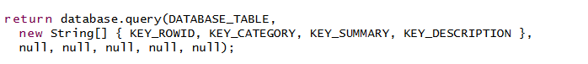
DAO class is responsible for database connection and accessing modifying the database object.

Creating Android Project

Creating the new android java based project which leads to executes on mobile application framework, so the desired requirement of creating the projects as follows:
- Creating Android new project
- Name the project like SQLITE app
- Create a new GUI framework
Followed by these java classes as follows:

- Main activity java class
- DB Helper Java class
- Activity main XML class

Content Provider and sharing data
SQLITE database is privately works on java class to create and update purposes, which essentially demands of every application. Content provider allows application to access data within the object class.

Android SQLITE database component
(Musle & Zain, 2018) mobile application becoming gaining more popularity in these days due to emerging the IOT devices and mobile devices in the wireless computer network but there is need to improve the WIFI internet connection security. Android studio offers wide verities of packages that comes with JDK tool kit and android application tool kit which support mobile application execution method. Android database component facilitate to support SQLITE database component which require tools and technique method to execute the method. Android SQLITE creator tool which automatically generate the SQLITE database. SQLITE works on principle method of API classes that perform the read write operation. (Sooman Jeong, 2013) Android input output stack consist of various essential component that used to elaborate the SQLITE database system interrupt driven input output operation sustain the working behavior of file system that evaluates the database input output file system operation. SQLITE propose to automatically build the Android database applications that no needs of extra configuration and management of any application wizard. SQLITE database input output operation performance is 300% better than other databases till. (Shahriar, 2014) Content provider escape susceptibility detection in android application has been addressed in this research. Android operating system malware detection system works 100% better than windows operating system.

Data Collection Method

Primary Data:

Primary data used for creating android mobile database application which stores the real time primary data of the students. Primary data collected by using the SQLITE database mobile applications in real time execution method of app, android studio offers to store the primary data that integrate with SQLITE database suits backend to create and automate the database system that leads to store the primary record within the SQLITE database table in the real time execution of application running.

Secondary Data:

Secondary data used in this research for reading the impact factor articles including peer review journal article, the peer review journals article contains with ACM digital library, IEEE XPLORE and MDPI Research. Secondary data has been collected by using the Google Scholar research engine. IEEE journals sites is one of the best leading website contain secondary data of research which essentially used to develop the research literature and other method.

Data Analysis Method

Android application data analysis method which analyze the working performance of SQLITE android application. (Gautam, 2021) The advancement of artificial intelligence that comes with machine learning and deep learning method which essentially used to optimize the result. The arrival of mobile application that change the method of operating system and user experience has been changed. Machine learning and AI method used to boost the application running times which essentially needs for every mobile user applications. The student database record applications is starting and beginning point of application running which required no additional machine learning algorithm models, if the data size is increase and contains in huge size then there is need of optimization method which needs to executes the application running times fast comparatively to engage the application user interface system. By using the mobile camera to integrate the bar code reader that presents in product scanning in the online shopping products system. the online grocery applications is one of common choice of mobile user that needs to buy something new products, the arrival of vast varieties of mobile application that downloaded from Google play store so the comparison is complex to validate the best choice of online grocery application. (Kurniawan, 2021) Android application has been analyzed by using the cubic structure with lattice parameter of crystal structure the application build with c programming interface using the system algorithm to optimize the coherent crystal structure of mobile applications.

The Effect of Android Studio

(Duwi Sulistiani, 2021) In corona virus pandemic situation various mobile application based method has been used to identify the disease and effected areas of the covid19. Various mobile based database applications has been used to optimize the different record of the patient in real time central database system that needs to provides the essential information to the user. SQLITE database processing and running time faster than other database applications program. (Herath, et al., 2021) Android based indoor navigation system used by various shopping malls to boost up the shopping business and other needs, augmented reality application merged in android application platform which uses to optimize the various certain operation. The feature of different functionality that works on different parameter to achieve the goals of shopping and buyer to buy certain product with augmented reality based suggestion and solutions. Various smart phone contains with virtual reality and augmented reality based system that support café’s and restaurant to sell their products with confidential data and information. Android based indoor navigation system which support shopping center to validate and update the different protocol method to achieve the certain goal of business prospect. The development of database application with wide verities of android SDK tool and technique support the database system to record the real time record in SQLITE database. (Putra, 2020) Android based fertilization system used to guide them properly in order the optimize the record of various certain operations the availability of cultivation palm oil sustain to record the various fertility operation navigation system which is android based application backend SQLITE database connected to record the performance. The large amount of fertilizer and large evaporator system connect with IOT system and the system connected with mobile based application to view the certain objects and parameters of oil fertilization and palm fertilization method achieve successfully. The result of this study based on android application which proceed the stock and flow diagram execution.

Automating and Analyzing Code in Android Studio

(projects, 2021) Types of code checking in android studio so there are two method to checking the code in the android studio.
- Static code analysis (without starting the application)
- Code analysis while running the application in android studio.
Android development works with java based SDK development kit which used to develop the mobile application which proceed in mobile operation system which based on android operating system. Latest android version contain stable development of various database operations. The static code testing dynamically test and verify the codes in android studio which needs to test and validate them, various code analysis tools available that mitigate to process the certain operations in the development of programming applications, according to software development life cycle method the achievement of verifying and testing the different software module was mandatory which uses to test and update the software system.

Database SQLITE Mobile Application

Creating and updating database in android studio which needs no extra effort android studio automatically generated SQLITE query and connect with database server with DAO class. Data access object class used to establish the database connection in android studio with java class activity. Beside this xml based method used to prioritize the method of data submission in real time running database application. (Studio, 2021) SQLITE query method joint with cursor query method to insert () update () and DELETE () the object if the application required certain query processing operations.

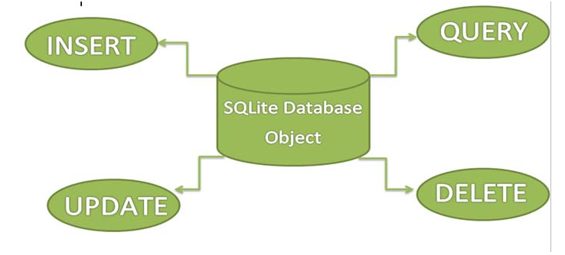
Figure 8: SQLITE Database Objects

SQLITEOPENHELPER class uses the java class method with super () class method along with construction to call the object to retrieve them in application via using the exception handling method. SQLITE in android studio essentially provides the two method such as on create method and on upgrade method. The SQLITE open helper method used to verify that if the database is not exits then it’s create them automatically to validate the outcomes and enhance the performance of the database including java based method. Activity XML view class used to manage the GUI application and buttons to creates them in order to process the text data in object of various GUI classes to present the outcomes of the application with certain query processing operation.
- Text view
- Edit Text
- Button
- Edit Text view
- Text View
- Relative layout of the application
SQLITE further obtain with database class and java activity class followed by the method of xml class method. SQLITE open helper query method used to optimize and prioritize the outcomes. SQLITE uses light weigh data to retrieve the front end application because of its low data capability in size, its compatible with all android applications to develop the essential android based applications. Java activity class communicate with database activity class and followed by the method of XML operations. The java method classes operate the input query operation and output query operation to achieve the goal of CRUD application, in order to executes the query processing operation of create read and update and delete operation followed by the certain database query operations that essentially used to operate them successfully.

Outcomes of Database APP

Predicted Application outcome:
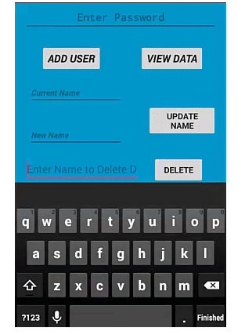
Figure 9: Predicted outcomes

Sources

The sources used in preparing this research project as follows:
- Google Scholar
- IEEE XPLORE
- IEEE Site
- ACM Digital library
- MDPI Research
- Android Studio
- SQLITE database
- JDK java development kit version 14.0
- Setting up the java environment variable system in windows operating system to achieve the android execution method. Java development kit used to execute the android application in windows operating system.
- Running Java software development SDK kit is basically essential component of every application.

Ethical Concern

I promised that this research work is originally written by me, under the law and order of UK data protection act. This works is not copied from other resources and journals sites, I get the idea and cite them. This research does not harm any human being during development of running mobile database applications, this works does not support any stakeholder and funding agency to proceed them as a profit purposes. This works design to establish the thinking capabilities of the mobile generation user, it works to enable the critical thoughts amongst the student that will takes interest to deploy the advance database software engineering method to present database work. This project introducing the student in the way of thinking database, so it is carefully observed that the research study present that mostly academic level students uses mobile apps to executes studies related task, so in order the interest of new thought and method the application made.

Chapter # 4: Result & Analysis

Mobile application development commonly practices in these days, mobile database stored in lightweight database which is known as SQLITE database system, connected with android studio ARC Fox 2021 version, which considered latest version. The mobile database development system stores light application data which normally considered user registration, login registration etc. various mobile applications needs user registration which required to store the user data into the database system. The database development system essentially needs to store in the backend database which automatically connected in real time android application and android studio. (Kussainov, A.S., 2021) computed application compile by using the latest SDK version of java to execute the android mobile database application. The activity of interface development to achieve the outcomes of database development with respect to achieve the great outcomes of database development in order to store the real time student record.

Figure 10: Android studio
To survive in the application change various database driven application has been connected by default to run the current task, android studio have the built in capability to connect and store SQLITE database in order to achieve the execution of running target applications. The mimic interface of backend projections needs to connect with design component and code component by default if there is any changing exist so the application configure and update automatically. The result of back projection save the resultant image in the computer drive to execute and deploy the application later if any changing exist. (Saito, Y., Uemura, Suzuki, N., 2021) android application stores and retrieve the general purpose application to retrieve the student record. Using the Google map API interface the application needs to execute in the software development kit using the location of azimuth data to execute the application in various time frame.

Installation of android SDK

Android studio arctic fox needs to installed latest SDK to proceed the mobile application development interface, various software development kit application library and java run time environment needs to installed and executed within the android project application. Android SDK based on the latest version of the mobile application development. Various application needs to install to execute the various database application and different task applications. In previous releases android SDK written in c and c++ programing forum.

Installation of Android Gradle

Android Gradle is known as operating system kernel like application in which mobile operating system applications needs to execute them on android studio Gradle. The Gradle library downloaded and installed automatically during the android project creation, due to recent advance Intellij idea java application web based software engineering application achieve the great outcomes. The extended applications of android needs the Gradle environment to execute the graphic like application within a system. The achievement of great development process has been achieve the great outcomes.

Installation of Emulator

The emulator is used to execute the real time android development application. Android emulator which is part of android SKD tool kit. Emulator fixes the previous issues and resolve them in order to obtain the outcome that executes on mobile development platform. Android Gradle 30 version is updated and configurable and manageable due to its flexible and reliable GUI based application running environment.

Issues & problem in Emulator

Android studio compatibility version issues exists due to the version compatibility with windows operating system, somehow the application might be fixed due to uninstallation process of version of emulator which does not compatible with the latest version of android studio

EMULATOR installation process:

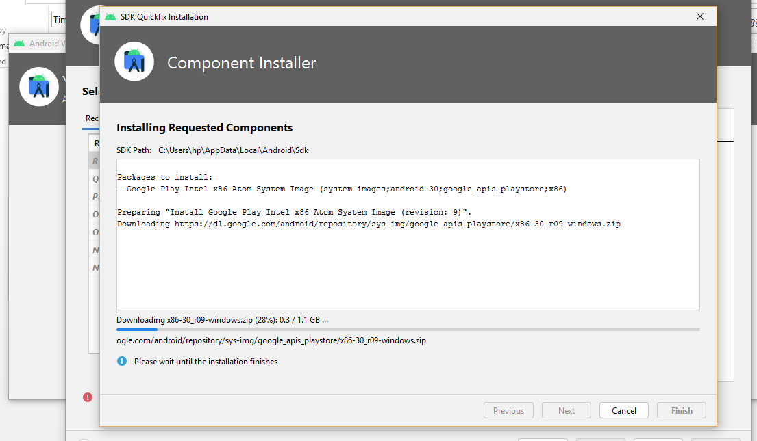
Figure 11: emulator installation wizard.

Android Application

Android application development (BRANO 2021) present thesis for deploying music player application using the android studio application which essentially used to listen music by using the Google API online to retrieve and fetch the music with running on demands library index engine.

Google Play Store

Google play store needs to execute all of the latest mobile application which is based on latest emulator version, the Google API services and plugin services layer has been built in available in the mobile operating system in order to achieve the great outcome of the application.

Android Operating System

Android operating system developed by Google, which is essentially known as well reputed tool and operating system, beside this most popular Google applications has been enable the user .

Android SQLITE Database

(Musleh, I., Zain, S., 2018), android studio essentially automatically generate the SQLITE database which is built in feature within the android studio application runner environment. Android SQLITE CREATOR is internal Google API library which executes online within the android studio to create the database application on demand running the application which is recorded the student database and student record in the form of text string.
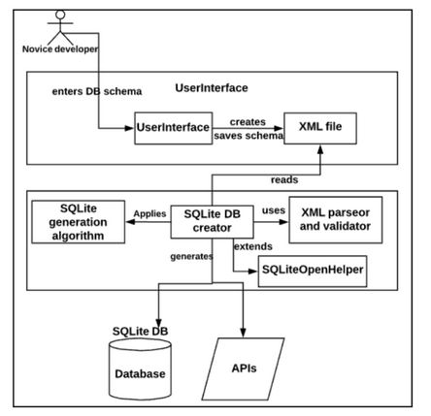
Figure 12: User interface of application

Flutter Smart Code Dart (Plugin Configuration)

Dart is recognize as smart coding assistance in android studio that includes code completion formatting, navigation, integration, refactoring purposes. The IDE detects the problem in the code , on the run time code execution session, It suggest automatically clean and fix the bug in the code. It also includes the run and debug test code session. Flutter uses to develop cross platform mobile application, which support developer to deploy coding in suggestive way and in more organized manner to do the task in organized manner.

Main Activity Java Class
Main activity java class used to control all of the internal constructor operation in between the XML class.

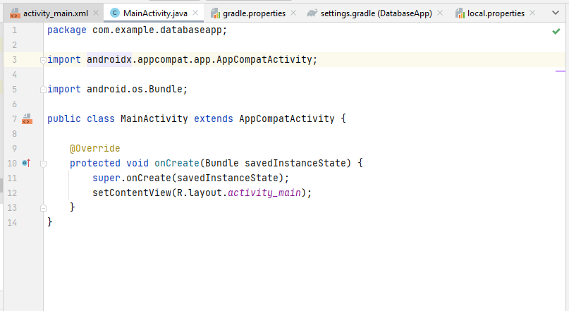
Figure 13: Main Activity Java class

Android Manifest XML
Android manifest xml class used to obtain the database launcher to control and manage the database activity class as well as control the android application server classes.

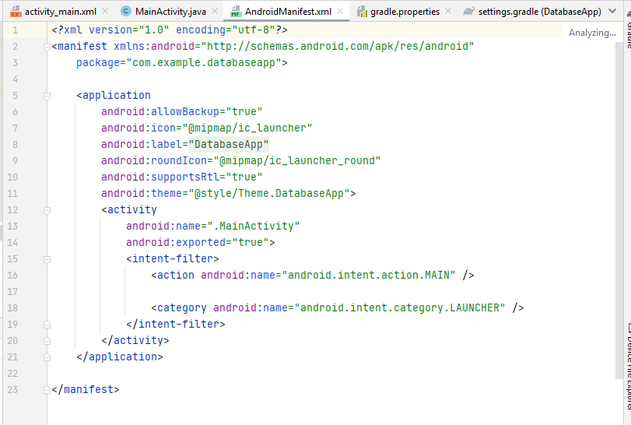
Figure 14: Android Manifest

Implementation in Android Studio (Result)

The following outcome designed in android studio arctic fox version 2021, this is only database design text field, in which various plugins, emulator, SDK has been extracted and downloaded. It will produces the database critical thinking objects in the student community.

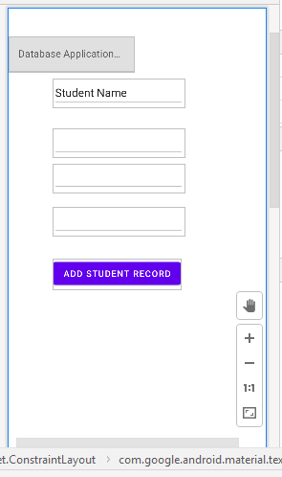
Figure 15: Database Design application outcome

XML Code View

The XML code view is used to add the text field, capability and various operation in which the target application needs to run and execute them.

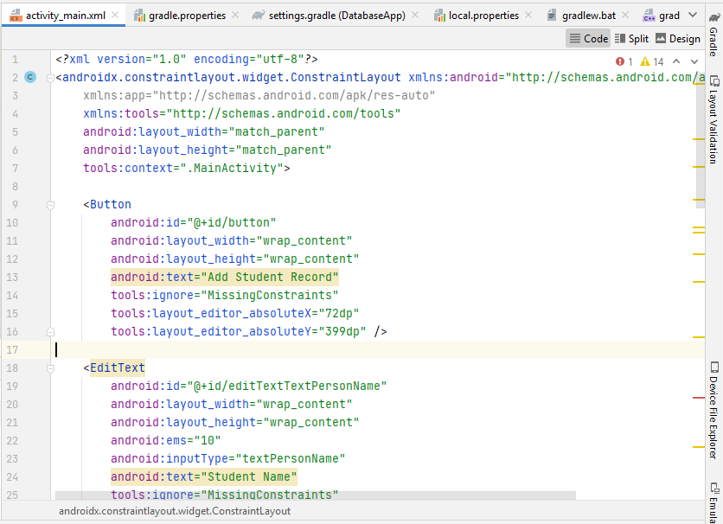
Figure 16: activity xml

Example Unit Test Java Class

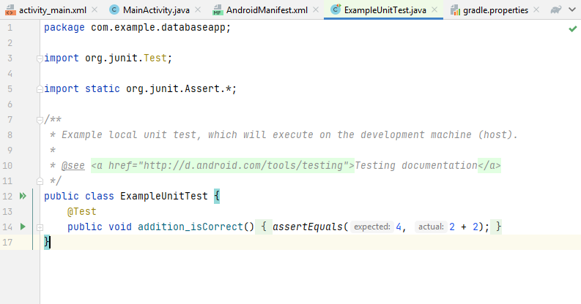
Figure 17: Example unit test java

Setting Gradle for Android Studio

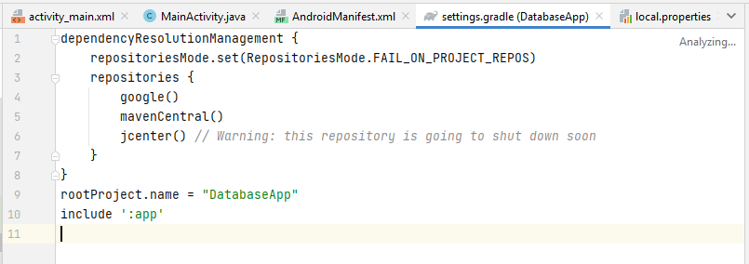
Figure 18: setting gradle db

Result

The resultant database application based only in database design text portion, so future research require in order to execute the novel android arc studio 2021 plugins and other emulator issues.
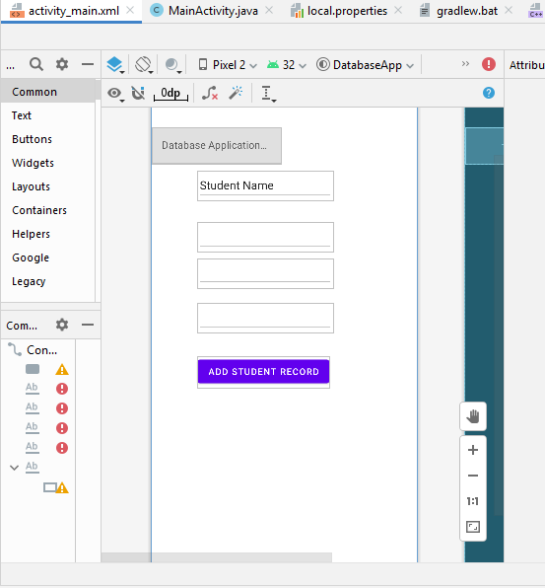
Figure 19: Outcomes

Analysis

(Lee, S., 2012) mobile application essentially needs to execute with various plugins and Google API layer in which different business logic & classes has been attacked to build the database class. Flutter tool was essentially used to build the mobile virtual assistance device to view the running task in which the xml code has been produced. Various android database design application needs different text panel and button design system in which the pattern of goal has been analyzed in view of developing the real time application always challenging question in order to optimize and prioritize the database application. (Musleh, I., Zain, 2018) the automatic generation of database application generate the SQLite database connection all of the text database table classes has been created by default in the android studio application environment. The database application run time environment store and view the text data, SQLITE database considered as light weight database, various development and implantation has been always challenging part, so the development interface of the database application and system development operate the various tools and operation to achieve the running target to develop the sustainable running database app. (Obradovic, N., Kelec, 2019) database performance analysis has been very important to execute any application, without database exist there is not possible to run any app and software, various web based application is being developed in Java and Kotlin environment, various mobile application development has been very serious and challenging task for the software developer, so this project is only design the database interface so database record saving projection needs more complex programming and coding, so at this level the projection of android development environment has been design with text fields input fields and submission button field. The database CRUD operation has been performed on unencrypted database in order to run and executes the application that achieve to deploy the real world task that perform the different CRUD operation has been very complex and challenging task at student level. CRUD application designed using the android studio in which Google play store verified the android version and execute and publish them for other researcher. SQLITE database has been published by the Google Play store, in which the unencrypted text data has been stored and view in real time application by using the Google online API. The SQLITE database provides thee 45% more accuracy comparatively to other relational database system other relational database contains various issues and problems, but the SQLITE database has been solved development issues.(Li, Q., Hu, X. 2014) database management and recover system needs other optional framework and plugins in order to plan the database security and backup, so the online execution of various database running task no need to backup and security due to secure virtual private network of the Google layer. In digital forensic science the deleted record was considered challenging problem, but the investigation science agency has been solved this issue, by planning the proper database framework in which various tools and technique has been workout. The database operating record by using the WAL method that produces the high quality outcomes, database recovery method by using the ext4 file system method thus constructing the real time database timeline, the experiment images has been described the deleted entries which helps the forensic science agency to investigate in more depth. (Allen, G., 2021) android devices two major component to develop and retrieve the database application, the fully fledged database executes on relational database pattern, SQLITE and android database content provider deal the internal linked framework which was based on content information system, that stores, retrieve and view the real time text data operated in the input text field of the android application. The internal android studio content provider interlinked with the android studio running environment to achieve the goals of the content information that readable and readily availed for the user view content system. (Song, F., 2020) mobile learning and real time map learning system based on android system ,various learning management system of universities at UK directly connected and interlinked with the student mobile devices which provides the content management information and learning aid tools and lecture notes facilities on fingertip. Various online portal sites and universities exam system also connected during the COVID pandemic to save the time and cost and execute the security as well, development online virtual assistant and virtual study assistant developed with the help of GOOGLE API, various problem has been solved if any critical issue occur. The development of mobile learning application vastly developed various universities because most of the students using mobile operating system, they does not required any tablet and PC laptop to view the course content and lecture notes, so everything is now considered and operate using the mobile application development, all web based learning system also integrated and attached with every android phone. The goal of developing the awareness and critical thinking amongst the student community has been achieved in this research by introducing the mobile development platform only design part, the designing and visualization part has been used to help and assist the student objects and developed the critical thinking environment between the student communities to achieve the better software development goal.

Chapter # 5: Discussion & Conclusion

(Musleh, I., Zain, S., 2018) mobile application is becoming more attractive with advantages of smart computing application merged with smart phone technology, the development of smart phone application enable the user to proceed the various task and operation in order to optimize the database system. Comparatively to other mobile application such as Apple, the android user is more than that due to the low cast and high compatibility application, the technology merging and convert with other application. The android user application experience is becoming gaining more popularity and attractions. The database application is only based on design part of android studio, due to the novel development of emulator functionality and other java SDK functionality needs to revisit again to improve the component functionality. SQLITE database known as light weight database due to its huge amount of mobile development application, android studio connect and generate automatically SQLITE database due to SQLITE database helper class, the novel approach with development functionality of Java KOTLIN and FLUTTER, provides the better interface of development by using the mean of mobile application development. Particular types of tools and technique by using the mobile application development always depends on best suit development in the objective of execution of running application on Google play store. To assist the developer the research is going to help students in which engage and develop critical thinking strategy to develop mobile apps. Android database components present the technique of SQLITE database component with using the Google API layers functionality. The technique of ANDROID SQLITE database creator needs more improvement due to emulator installations issues in Arctic fox version of android studio, various emulator and plugging issues is being challenging task to deploy the android tools and application. So the issues is still remain to ask from the mobile developer to resolve the emulator and SDK issues which sometimes crashes and damage and might be able to damage the overall application within the android studio platform. (Wu, S.S., 2011) the design of intelligent pedometer by using the android application, Google Android is recognize as leading platform of mobile platform in the smart phone computing framework. Comparatively with other operating system, android releases new android version to enhance the kernel capability and security and performance features within the android phone operating system. Google operating system offers reliable and sustainable application platform that rich with all GOOGLE online API layer to process the complex application within the android smart phone. Android operating system also offers to design mobile sensor applications by using the artificial intelligence and machine learning based algorithm, the arrival of virtual reality and augmented reality features also provides the advance support in android phone of SAMSUNG. The pedometer known as auxiliary device used to formatting the health and fitness operation. The user walking motion is detected by the mobile sensor it connected with the central internet to proceed the information to other network. The system also connected with Bluetooth device to send the signal to other device it contains three major functionality, action mode, and time based mode, distance based mode, and count based mode all tracking service has been saved in SQLITE database which is connected through the GOOLGE API layer. (Ma, L., Zhuo, 2014) digital campus management system which is based on android phone system capable for doing the campus management task by means of learning management system through online content management that leads towards the learning capability amongst the student community. Digital campus management system essentially support the student community in which various student can takes interest to deploy the learning capability, also support the online answer & questioning session. The online session support the content management system, which enable the student to shares various lecture notes, slides, and other practical task work between the pole of group studies and individual studies group. The matter is concerned on major issues to resolve the various issues of studies and other practical programming task needs more attraction and more correspondence , the content manage system fully integrated with campus management system modules that contains the teacher lecture notes and video lecture. The information sharing through the mobile based projection has been highlighted and the development of SQLITE database backend to support campus management system to store and retrieve the various functionality of the student component.

(Wang, C., Wang, C., 2011) mobile phone technology recognized as portable computing technology which contains the important features of communication and sharing features, it also used to facilitate the student community for learning and projection of different programing task by using the online portal service, the arrival of web 2.0 has been introduce the Facebook, YouTube and other social channel network that leading sites support the studies related matter and other situation to control and manage the situation. Beside this cloud computing offers various storing services without buying additional storage hardware system so the arrival of smart phone based on android functionality solves the all situation special student community takes interest to participate in the learning session. The goal of database implementation process and procedure used to introduce the functionality of various software engineering tools and technique. This thesis talk about the android phone structure with the help of SQLITE database system, android operating system developed by Google, which is known as one of the best leading operating system developer of 21st century. (YIN, J. WANG, H., 2012) data storage based on android operating system that enable various cloud computing providers to facilitate the online user to store and retrieve service on Google Cloud, Amazon Cloud, Azure Cloud and Dropbox system. Android operating system based on Linux operating system which known as open source operating system. Due to rapid development of android operating system facilitate the user to develop different kind of applications but the issues is still remain due to android studio compatibility issues with the windows operating system. Android development is mainly provides the data storage facility to the user file storage and SQLITE database storage service content provider storage and network storage services. (Chen, Z., Wei, B. 2020) travel assistance application based on android Baidu app. Smart phone is playing leading roles in the development of tourism, Google map services automatically integrated with every android smart phone it support the free of cost map and location service with encryption method, to obtain the high resultant values which unitize the component based delivery to manage the application. The tourism app uses the embedded SQLITE database in order to process the BAIDU Map service which support the client computer to initialized with the tourism service sites and book any kind of place and place order and booking flight with payment module as well online method. The SQLITE database works on point of interest and content deliver management which based on text based service. To display the request and store the user request in the internal SQLITE database system needs no extra effort with application service management. (Chukwuebuka, J.E., Deng, J., Ejiyi, T.U 2021) design and development of android application to support educational institutes in these days which solves the complex problem by content management system and online learning system. Various universities offer online lecture management system, and other studies related portal services offer student to facilitate their educational career. Android has 76% of mobile user from December 2018 to December 2020. Android phone recognized as most useful mobile services that used by mostly the student community as well as business community to proceed their task. Students are part of higher education studies at academic contains with built in rich application of mobile phone which support the user requirement and needs.

Conclusion

Android database application design part by using the arctic fox android studio 2021 version which contains various issues of emulator and SDK. So the challenging part of enabling the student critical thinking capability by building the visual aid tools and technique method, so it has been workout and analyzed with the literature that student needs mobile services and interested in mobile application development, so this thesis support and introducing the students think about novel approach of building database by mean of android platform. Android application development contains with GUI layer and backend execution method based on XML based coding file. The XML file contains to support java activity and database helper class. The design interface control and mange by the XML based design activity to retrieve and design the text box of input values to store the student information on backend SQLITE database system, SQLITE database automatically connected with android studio application during the run time environment, comparatively with other database application its 500 time much better than other database system application. So the issues of emulator compatibility during the installation of android studio is still challenging and complex issues, to the community of jet brains need to improve the android studio functionality in order to facilitate the novel student to deploy database application without facing any emulator and plugins issues. So the third party tool name flutter offers mobile application development services within the android studio platform enrich to execute the virtual device assistance. So the future research requires to improve the development interface of android studio application environment and also future research required to improve the Java development process in order to optimize the java mobile application run. Comparative to other web application such as SPRING and SPRING Boot of java is much better than with android studio application.

References
Aaron & sella, D. l., 2019. Development of a cost-efficient waste bin management system with mobile monitoring and tracking. International Journal of Advanced Trends in Computer Science and Engineering, 8(9), pp. 1-8.
Ahmad, M. A., 2021. Couple Construction Model as an Alternative of Improvement Method Due to Failure and Defect of Cohesion Parameter (C). Applied Research on civil engieering and environment, 2(2), pp. 1-3.
Amasha, M. A. M. K. D. A. S. A. S. a. A. R., 2021. Development of a Java-based Mobile application for mathematics learning.. Education and Information Technologies,, 26(1), pp. 945-964..
Avdic, A. a. E. A., 2010. Searching reference databases: What students experience and what teachers believe that students experience. Journal of librarianship and information science, , 42(4), pp. .224-235..
Chien Yu, T. B., 2011. Multimedia Database Applications: Issues and Concerns for Classroom Teaching. The International Journal of Multimedia & Its Applications, , 3(1), pp. 1-9.
databases, T. h. o., 2021. The history of databases. [Online]
Available at: https://www.thinkautomation.com/histories/the-history-of-databases/
[Accessed 22 December 2021].
dbms, M., 2021. mobile dbms. [Online]
Available at: https://www.slideshare.net/Tech_MX/mobile-dbms
[Accessed 21 December 2021].
Duwi Sulistiani, S. R. R. A. Y., 2021. The Effect of Android Studio Application to Increase Adolescent Nutrition Knowledge. Public Health perspective journal, 6(2), p. 1.
Estévez Ayres, I. A. F. J. U. G. L. A.-H. C. a. D. K. C., 2018. Uncovering flipped-classroom problems at an engineering course on Systems Architecture through data-driven learning design.. Uncovering flipped-classroom problems at an engineering course on Systems Architecture through data-driven learning design., p. 1.
Fung, D., 2014. Promoting critical thinking through effective group work: A teaching intervention for Hong Kong primary school students. International Journal of Educational Research, Volume 66, pp. 45-62..
Gautam, S. G. P. G. A. K. M. a. B. T., 2021. SMART SHOPPING APPLICATION USING ANDROID STUDIO AND UNITY.. IEEE Journal of Science & Technology, 6(1), pp. 399-405.
Gezgin, D., 2019. The effect of mobile learning approach on university students' academic success for database management systems course.. International Journal of Distance Education Technologies (IJDET),, 17(1), pp. 15-30..
Gezgin, D. M., 2019 . The Effect of Mobile Learning Approach on University Students' Academic Success for Database Management Systems Course. International Journal of Distance Education Technologies (IJDET), 17(1), pp. 1-16.
Ghorbanzadeh, P. S. A. M. R. a. J. Z., 2010. A survey of mobile database security threats and solutions for it. In the 3rd International Conference on Information Sciences and Interaction Sciences IEEE., pp. 676-682.
Hadley, G., 2002. An introduction to data-driven learning. RELC journal, 33(2), pp. 99-124..
Hambrusch, S. H. C. K. J. H. M., 2009. A multidisciplinary approach towards computational thinking for science majors. ACM SIGCSE Bulletin,, 41(1), pp. 183-187..
Herath, H., Wanniarachchi, A. & Fernando, R., 2021. Research Direction for Android Based Indoor Navigation olution for Shopping Malls through Augmented Reality-EasyMap. KDU IRC 14th International research conference, pp. 1-10.
Jiao, T., 2021. Mobile English Teaching Information Service Platform Based on Edge Computing. Mobile Information Systems, 2021., pp. 1-5.
Kurniawan, A. a. I., 2021. Android based XRD data analysis software design for cube crystal structure with analytic and Cohen methods.. In AIP Conference Proceedings AIP Publishing LLC., 2320, (1), pp. 1- 030001 .
Lei, D. & Feng, Y., 2002 . An architecture for mobile database management system. International Journal of Minerals, Metallurgy and Materials , 9(2), pp. 156-160 .
Li, P. Y. Z. Y. W. Y. M. H. M. Y. Q. L. K. Z. J. L. T. C. D. a. Z. Z., 2019. A clinical-grade mobile health system for cardiovascular disease management.. In 2019 IEEE International Conference on Healthcare Informatics (ICHI) IEEE., pp. 1-6.
M. Sheerin Banu, A. P. D. J., 2021. DEVELOPMENT OF MOBILE APPLICATION FOR GOVERNMENT SCHEMES MANAGEMENT. International Journal of Modern Agriculture, 10(3), pp. 1-10.
Madbouly, M. M. & Yasser, 2021. Quantum Game Application to Recovery Problem in Mobile Database. Symmetry MDPI research journal, 13(11), p. 1.
Manson, S. S. J. E. S. K. L. D. K. N. S. B. L. B. D. K. M. I. J. a. M. L., 2014. Resource needs and pedagogical value of web mapping for spatial thinking. Journal of Geography, , 113(3), pp. 107-117..
Maps®, T., 2021. Thinking Maps®. [Online]
Available at: https://www.thinkingmaps.com/
[Accessed 20 December 2021].
Modeling, D. D. i. D. T. L. D., 2021. Database Design in DBMS Tutorial: Learn Data Modeling. [Online]
Available at: https://www.guru99.com/database-design.html
[Accessed 21 December 2021].
Musle, I. & Zain, S., 2018. Automatic generation of android SQLITE Database component. New trends in software methdologies tool and techniques, pp. 3-15.
N. Dorosh, H. K. O. B. O. D. O. S. a. N. M., 2016. Development the software applications for mobile medical systems based on OS android,. 2016 13th International Conference on Modern Problems of Radio Engineering, Telecommunications and Computer Science (TCSET),, pp. 808-810.
projects, A. o. c. a. i. A., 2021. Automation of code analysis in Android projects. [Online]
Available at: https://proandroiddev.com/automating-analyzing-of-code-in-android-projects-a60313569c53
[Accessed 22 December 2021].
Putra, D. B. M. S. A. S. T. a. P. B., 2020. August. Simulation of Availability and Loss of Nutrient Elements in Land with Android-Based Fertilizing Applications.. In 2020 International Conference on Information Management and Technology (ICIMTech) IEEE., pp. 312-317 .
Qiao, Y. X. Z. F. Z. Y. J. a. K. N., 2018. Characterizing flow, application, and user behavior in mobile networks: A framework for mobile big data. IEEE Wireless Communications,, 25(1), pp. 40-49..
Rodriguez, J. M. A. Q. J. a. H. C., 2017. Distributed architecture of mobile GIS application using NoSQL database.. Int. J. Inf. Electron. Eng,, 7(6), pp. 156-160..
Romashkova, O. a. P. E., 2019. Resource management in distance and mobile education systems. In ITTMM (Selected Papers), pp. 102-108 .
Scardamalia, M. B. C. B. C. B. P. C. C. a. L. N., 1992. Educational applications of a networked communal database. Interactive learning environments, , 2(1), pp. .45-71..
Shahriar, H. a. H. H., 2014. Content provider leakage vulnerability detection in Android applications.. In Proceedings of the 7th International Conference on Security of Information and Networks , pp. 359-366 .
Singh, P. K. & Shanker, U., 2021. Transaction Issues in Mobile Distributed Real-Time Database Systems. Recent Advances in Computer Science and Communications (Formerly: Recent Patents on , 14(4), pp. 1127-1149.
Somantri, S. Y. I. a. N. A., 2020. Electrical Consumption Monitoring and Controlling System Based on IoT and Mobile Application. In 2020 International Conference on ICT for Smart Society (ICISS) (pp. 1-5). IEEE., pp. 1-5.
Sooman Jeong, H. U., 2013. I/O Stack Optimization for Smartphones. USENIX Annual Technical conference, pp. 1-5.
Studio, S. T. W. E. I. A., 2021. SQLite Tutorial With Example In Android Studio. [Online]
Available at: https://abhiandroid.com/database/sqlite
[Accessed 22 December 2021].
Thinking, E. S. f. C., 2021. Essential Skills for Critical Thinking. [Online]
Available at: https://www.teachbetter.com/blog/strategies-to-increase-critical-thinking-skills-in-students/
[Accessed 20 December 2021].
tools, D. d. /. R. E., 2021. Database diagram / Reverse Engineering tools. [Online]
Available at: https://dbmstools.com/categories/database-diagram-tools
[Accessed 21 December 2021].
Upshaw, D. H. M. a. H. E., 2019. LEARNING MANAGEMENT SYSTEMS AND MOBILE DEVICE SUPPORT.. ASSOCIATION OF COLLEGIATE MARKETING EDUCATORS HOUSTON, , 14(15), p. 52..
Villanueva, E., 2021. Nueva Ecija Provincial Health Office: Health Management System with Web-Based and Mobile Application.. Turkish Journal of Computer and Mathematics Education (TURCOMAT), , 12(10), pp. 636-654..
Vogel, L., 2010. Android sqlite database and contentprovider-tutorial. Java, Eclipse,. Android and Web programming tutorials, , Volume 5, p. 8.
Weider, D. a. S. S., 2007. A mobile database design methodology for mobile software solutions. In 31st Annual International Computer Software and Applications Conference , Volume 2, pp. 121-130 .

Kussainov, A.S., Em, M., Myrzabek, Y. and Mukhatay, M., 2021, November. Implementing the basic CT backprojecting algorithm in android mobile application. In Journal of Physics: Conference Series (Vol. 2090, No. 1, p. 012132). IOP Publishing.

Saito, Y., Uemura, S., Okuzumi, J. and Suzuki, N., 2021, November. ArrivieW2: an Android Application for General-Purpose Information Presentation Using Google Map API, Location and Azimuth Sensor. In 2021 IEEE International Conference on Artificial Intelligence and Virtual Reality (AIVR) (pp. 70-76). IEEE.
CHMELAŘOVÁ, B.G., ANDROID MUSIC PLAYER WITH THE SONG SELECTION BY A DEVICE CONTEXT.

Musleh, I., Zain, S., Nawahdah, M. and Salleh, N., 2018, September. Automatic Generation of Android SQLite Database Components. In SoMeT (pp. 3-16).

Lee, S., 2012. Creating and using databases for android applications. International Journal of Database Theory and Application, 5(2), pp.99-106.

Musleh, I., Zain, S., Nawahdah, M. and Salleh, N., 2018, September. Automatic Generation of Android SQLite Database Components. In SoMeT (pp. 3-16).

Obradovic, N., Kelec, A. and Dujlovic, I., 2019, March. Performance analysis on Android SQLite database. In 2019 18th International Symposium INFOTEH-JAHORINA (INFOTEH) (pp. 1-4). IEEE.

Li, Q., Hu, X. and Wu, H., 2014, June. Database management strategy and recovery methods of Android. In 2014 IEEE 5th International Conference on Software Engineering and Service Science (pp. 727-730). IEEE.

Allen, G., 2021. Working with Databases in Android. In Android for Absolute Beginners (pp. 323-343). Apress, Berkeley, CA.

Song, F., 2020, February. Mobile Learning System of Ideological and Political Education in Universities Based on Android. In 2020 12th International Conference on Measuring Technology and Mechatronics Automation (ICMTMA) (pp. 750-754). IEEE.

Musleh, I., Zain, S., Nawahdah, M. and Salleh, N., 2018, September. Automatic Generation of Android SQLite Database Components. In SoMeT (pp. 3-16).

Wu, S.S. and Wu, H.Y., 2011, December. The design of an intelligent pedometer using Android. In 2011 Second International Conference on Innovations in Bio-inspired Computing and Applications (pp. 313-315). IEEE.
Ma, L., Zhuo, Y., Liao, K., Liu, S., Qiao, J., Han, Z. and Wang, J., 2014. Development and research of digital campus system based on android. International Journal of Smart Home, 8(4), pp.25-36.
Wang, C., Duan, W., Ma, J. and Wang, C., 2011, December. The research of Android System architecture and application programming. In Proceedings of 2011 International Conference on Computer Science and Network Technology (Vol. 2, pp. 785-790). IEEE.
YIN, J. and WANG, H., 2012. Data storage based on android development. Digital Communication, 6.
Chen, Z., Wei, B. and Quan, J., 2020, December. A Travel Assistant Application Based on Android Baidu Map. In 2020 International Conference on Intelligent Computing, Automation and Systems (ICICAS) (pp. 299-303). IEEE.

Chukwuebuka, J.E., Deng, J., Ejiyi, T.U., Salako, A.A., Ejiyi, M.B. and Anomihe, C.G., 2021. Design and Development of Android Application for Educational Institutes. In Journal of Physics: Conference Series (Vol. 1769, No. 1). IOP Publishing.

Appendices (CODE)

Main Activity java

package com.example.databaseapp;
import androidx.appcompat.app.AppCompatActivity;
import android.os.Bundle;
public class MainActivity extends AppCompatActivity {
@Override
protected void onCreate(Bundle savedInstanceState) {
super.onCreate(savedInstanceState);
setContentView(R.layout.activity_main);
}
}

Android Manifest XML
<?xml version="1.0" encoding="utf-8"?>
<manifest xmlns:android="http://schemas.android.com/apk/res/android"
package="com.example.databaseapp">
<application
android:allowBackup="true"
android:icon="@mipmap/ic_launcher"
android:label="@string/app_name"
android:roundIcon="@mipmap/ic_launcher_round"
android:supportsRtl="true"
android:theme="@style/Theme.DatabaseApp">
<activity
android:name=".MainActivity"
android:exported="true">
<intent-filter>
<action android:name="android.intent.action.MAIN" />
<category android:name="android.intent.category.LAUNCHER" />
</intent-filter>
</activity>
</application>
</manifest>

Instrument Test java
package com.example.databaseapp;
import android.content.Context;
import androidx.test.platform.app.InstrumentationRegistry;
import androidx.test.ext.junit.runners.AndroidJUnit4;
import org.junit.Test;
import org.junit.runner.RunWith;
import static org.junit.Assert.*;
/**
* Instrumented test, which will execute on an Android device.
*
* @see <a href="http://d.android.com/tools/testing">Testing documentation</a>
*/
@RunWith(AndroidJUnit4.class)
public class ExampleInstrumentedTest {
@Test
public void useAppContext() {
// Context of the app under test.
Context appContext = InstrumentationRegistry.getInstrumentation().getTargetContext();
assertEquals("com.example.databaseapp", appContext.getPackageName());
}
}

Build.Gradel

plugins {
id 'com.android.application'
}
android {
compileSdk 32
defaultConfig {
applicationId "com.example.databaseapp"
minSdk 21
targetSdk 32
versionCode 1
versionName "1.0"
testInstrumentationRunner "androidx.test.runner.AndroidJUnitRunner"
}
buildTypes {
release {
minifyEnabled false
proguardFiles getDefaultProguardFile('proguard-android-optimize.txt'), 'proguard-rules.pro'
}
}
compileOptions {
sourceCompatibility JavaVersion.VERSION_1_8
targetCompatibility JavaVersion.VERSION_1_8
}
}
dependencies {
implementation 'androidx.appcompat:appcompat:1.4.0'
implementation 'com.google.android.material:material:1.4.0'
implementation 'androidx.constraintlayout:constraintlayout:2.1.2'
implementation 'com.google.android.gms:play-services-maps:18.0.1'
testImplementation 'junit:junit:4.+'
androidTestImplementation 'androidx.test.ext:junit:1.1.3'
androidTestImplementation 'androidx.test.espresso:espresso-core:3.4.0'
}
// Top-level build file where you can add configuration options common to all sub-projects/modules.
buildscript {
repositories {
google()
mavenCentral()
}
dependencies {
classpath "com.android.tools.build:gradle:7.0.4"
// NOTE: Do not place your application dependencies here; they belong
// in the individual module build.gradle files
}
}
task clean(type: Delete) {
delete rootProject.buildDir
}

Activity XML

<?xml version="1.0" encoding="utf-8"?>
<androidx.constraintlayout.widget.ConstraintLayout xmlns:android="http://schemas.android.com/apk/res/android"
xmlns:app="http://schemas.android.com/apk/res-auto"
xmlns:tools="http://schemas.android.com/tools"
android:layout_width="match_parent"
android:layout_height="match_parent"
tools:context=".MainActivity">
<Button
android:id="@+id/button"
android:layout_width="wrap_content"
android:layout_height="wrap_content"
android:text="Add Student Record"
tools:ignore="MissingConstraints"
tools:layout_editor_absoluteX="72dp"
tools:layout_editor_absoluteY="399dp" />
<EditText
android:id="@+id/editTextTextPersonName"
android:layout_width="wrap_content"
android:layout_height="wrap_content"
android:ems="10"
android:inputType="textPersonName"
android:text="Student Name"
tools:ignore="MissingConstraints"
tools:layout_editor_absoluteX="72dp"
tools:layout_editor_absoluteY="113dp" />
<EditText
android:id="@+id/editTextTextPassword"
android:layout_width="wrap_content"
android:layout_height="wrap_content"
android:ems="10"
android:inputType="text"
tools:ignore="MissingConstraints"
tools:layout_editor_absoluteX="72dp"
tools:layout_editor_absoluteY="192dp" />
<EditText
android:id="@+id/editTextNumberPassword"
android:layout_width="wrap_content"
android:layout_height="wrap_content"
android:ems="10"
android:inputType="numberPassword"
tools:ignore="MissingConstraints"
tools:layout_editor_absoluteX="72dp"
tools:layout_editor_absoluteY="248dp" />
<EditText
android:id="@+id/editTextTextEmailAddress"
android:layout_width="wrap_content"
android:layout_height="wrap_content"
android:ems="10"
android:inputType="textEmailAddress"
tools:ignore="MissingConstraints"
tools:layout_editor_absoluteX="72dp"
tools:layout_editor_absoluteY="317dp" />
<com.google.android.material.textfield.TextInputLayout
android:layout_width="200"
android:layout_height="wrap_content"
tools:ignore="MissingConstraints"
tools:layout_editor_absoluteX="1dp"
tools:layout_editor_absoluteY="46dp">
<com.google.android.material.textfield.TextInputEditText
android:layout_width="match_parent"
android:layout_height="wrap_content"
android:hint="Database Application Design" />
</com.google.android.material.textfield.TextInputLayout>
</androidx.constraintlayout.widget.ConstraintLayout>

Reflection
This research works is originally written by me no funding agency and other resources is not part of this research. my supervisor and my teammates help me lot for learning and development android based application, but originally I deploy this database design application, according to my effort, the learning point of view this research has been developed thinking power amongst the student community, and this research works is used as a learning aid and tools for upcoming students and research & scholars. This works is only concerned with to acknowledge the student thinking power and realize the student to do the works in more organized manner, due to the advance development of android application and android apps on daily basis, mostly all academic learning management system and content management system offering all of the services mobile based application so this idea has been coming from literature survey, so I wants to know about the novel and advanced technology has been deeply influenced in the student community so that why I decided to deploy atleast design part according to my own effort, if I copy and paste from other students then this works does not develop critical thinking skills in my mind. So only design part based on menu driven buttons and text input button in which the database design and storing design has been developed by using the latest android studio version arctic fox 2021. I have been learns from YouTube video channels and Google search engine helps me a lot for installing and downloading android studio application in my laptop computer. I have been facing lot of issues and challenges during installation of android studio in my laptop the exception handling occur , so removing exception handling takes times and the issues has been not resolved by trying so many times so I was committed that I cannot copy codes and instruction from someone else effort. I have decides that this research present my effort which has been based on database design application part. So later I have decided that I can learns more than my searching and thinking skills, so this research also enable my thinking capabilities how the software development and software engineers deploy interesting application by facing lot of problems and challenges, so the aim and objectives of this research only focused on the thinking capability so I realized that the thinking and developing is presented this work which is the main title of this research which I have presented to originally submit my work to university portal site. Database design and development part based on reverse and forward engineering concepts which is part of software engineering applications, various software developer teams automate the coding and deployment part to save the cost and times with less effort. In some situations the code might be reuse and some of the database applications might be able to reuse them to enable the software developer to save the effort. This research works is originally written by me no funding agency and other resources is not part of this research.

